**Practical Activity 3.1 [To be added in the lecturer guide]**

Add this as answer for question 2

Solution for question 2

JHB Metro Police Speeding Program

Solution

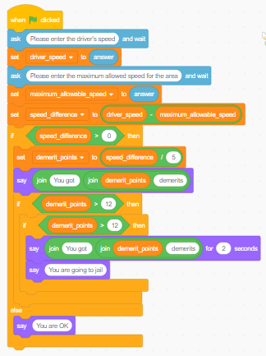

Add this as answer to question 3

Solution for question 3

The completed script for The Grading System is as follows:

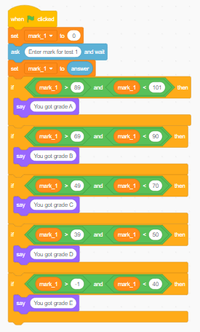

Add this as question 4 solution

Question 4

Solution

The completed script for The Bright Light Company Salary Calculator looks as follows:

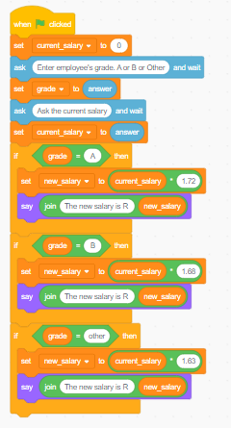

If you run the program using the given inputs, the result should match values in the expected new salary column in the table below.

|  |  |  |  |
| --- | --- | --- | --- |
| **Department code** | **Percentage increase** | **Current Salary** | **New salary** |
| A | 7.2 | 45000 | 77400 |
| B | 6.8 | 30550 | 51324 |
| other | 6.3 | 24800 | 40424 |

Add this as question 5 solution

Question 5

Solution

Here is the Scratch code to count digits in a number:

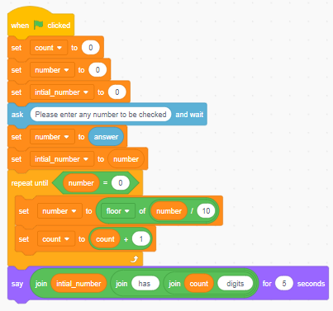

Add this as question 6 solution

Question 6

Solution

Here is the Scratch code for guessing a number

# Module 6: Data types, variables and output

